*Week 5 (23/10/2020): Skill*

*4.0. Introduction*

The designed game is a trivia-based game under a time constraint. Where questions increase in difficulty upon reaching the centre. To defuse the bomb, players are tasked to answer the most questions correctly within the time remaining in the centre.

*4.1. Materials*

To make our game, we would need the following. A timer that will start counting down as soon as the teams are ready to engage. This can either be programmed in our taken from a website on the internet. For future development, we would need more questions. This can be done from taking different types of questions from the internet or asking teachers or students.

*4.2. Rules*

Teams consisting of 1 to 4 players are needed before starting the game. The game is 8 minutes long; that means the bomb will start ticking down from the 8-minute mark. The team that correctly answers a question at hand will receive an additional 5 seconds which will be added to their overall time. There are 3 different categories for the questions; Biology, Mathematics and Geography. We categorized the difficulties of each question into 3 parts; easy, normal and hard. To add to that, 3 questions were made into each difficulty. For the easy difficulty, 3 questions must be answered correctly to move on. Normal difficulty only requires 2 to be correct to advance. Finally, the hard difficulty will only need 1 valid answer to defuse the bomb.

*Figure 4.4*

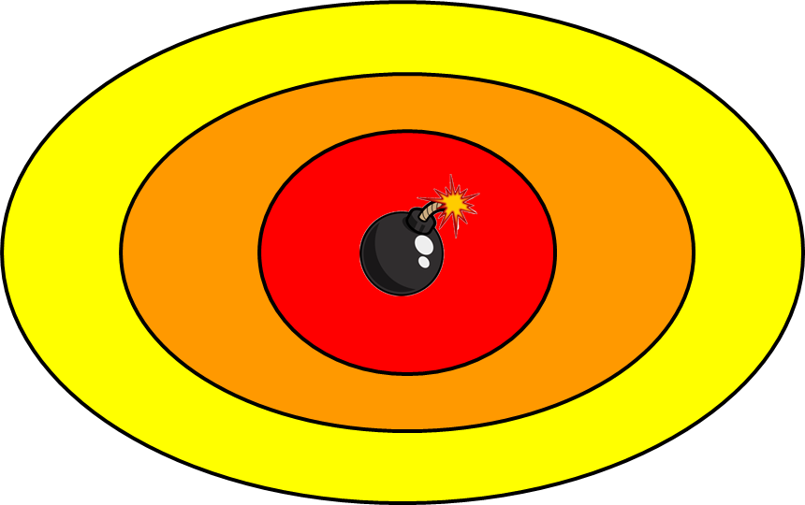

**Figure 4.4:** Mock-up game board. The yellow will be the starting stage with easy questions, the orange stage is the middle ground with medium questions, the red is the final stage where you are asked hard questions.

*Figure 4.5*

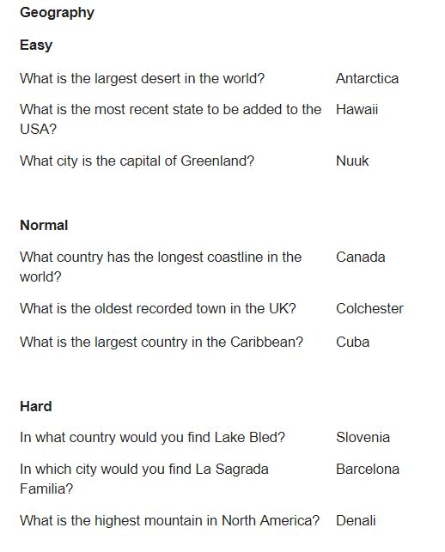

**Figure 4.5: Figure above shows 3 questions in each difficulty category for the Geographical section**

*Figure 4.6*

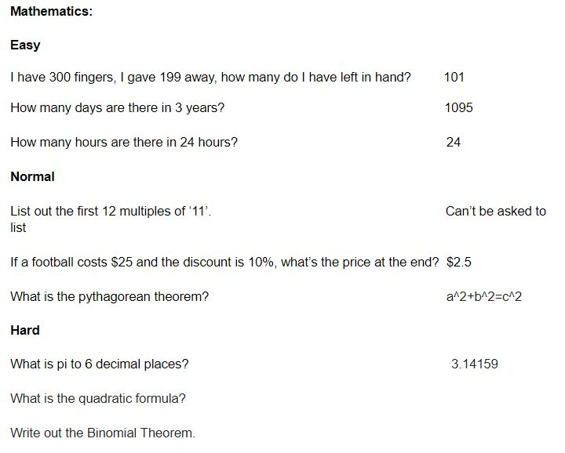

**Figure 4.6: Figure above shows 3 questions in each difficulty category for the Mathematical section**

*Figure 4.7*

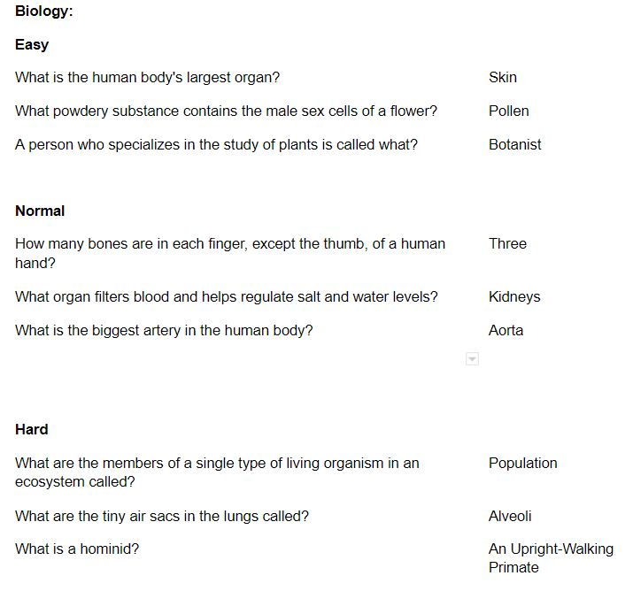

**Figure 4.7: Figure above shows 3 questions in each difficulty category for the Biological section**

*4.8. Play Testing*

As the team worked through internal play-testing, a few issues were found and later tweaked. For example, the final round needed players to answer 2 questions correctly to defuse the bomb. We changed this to where players answer as many hard questions as they can in a set amount of time. This was done because the game would end in a tie most of the time if we had not changed this.

As for external play-testing, we had compliments from another team; “The questions themselves were quite good and broad”. This tells us that the questions the team came up with were perfect for each category and difficulty.